In the Business Automation Navigator in the runtime instance, you configure a connection to the Application Engine. You also create or designate a desktop where you want to add your application or applications.

For applications that are based on the Document Processing (single document) template, you also create a root folder for your application, and configure permissions.

**Procedure**

To move your application to the runtime environment:

1. In your authoring environment, log in to Business Automation Studio.
2. If needed, create a version for your application:

You can skip this step if you have already created a version that you want to use.

* 1. Go to Applications, find your application, and use the Open link to open your application.
  2. In Application Designer, click the snapshot icon and choose Create a version.

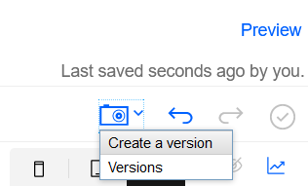

This step creates a version of the application in Business Automation Studio.

* 1. Return to Business Automation Studio.

3. Go to Applications, find the tile for your application, and double click the tile (instead of using the Open link).

4. Choose a version to export:

* If you want to export the most recent or tip version, click the three dot menu and click Export.
* If you want to export a specific version, highlight the version in the list, click the three dot menu on the list item, and click Export.

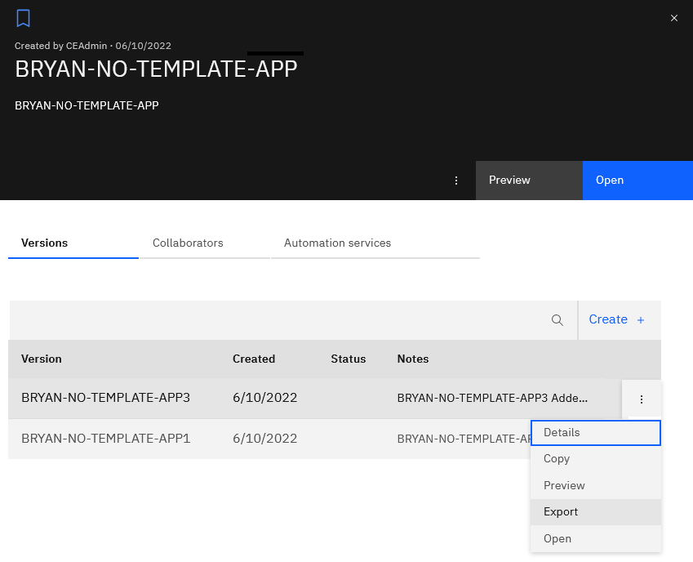

5. Choose Export this version to be published (.zip), and click Export.

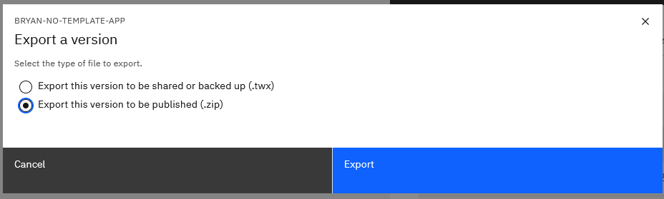

Save the file to a location on your client machine. If you have more than one application to export, repeat the steps for each application in your authoring environment.

6. In your new runtime environment, log in to IBM Business Automation Navigator as a Navigator administrator.

7. From the Navigation menu, click Connections.

8. On the Platform tab, select APPENG0, and click Edit.

9. In the General settings tab for APPENG0, click Connect.

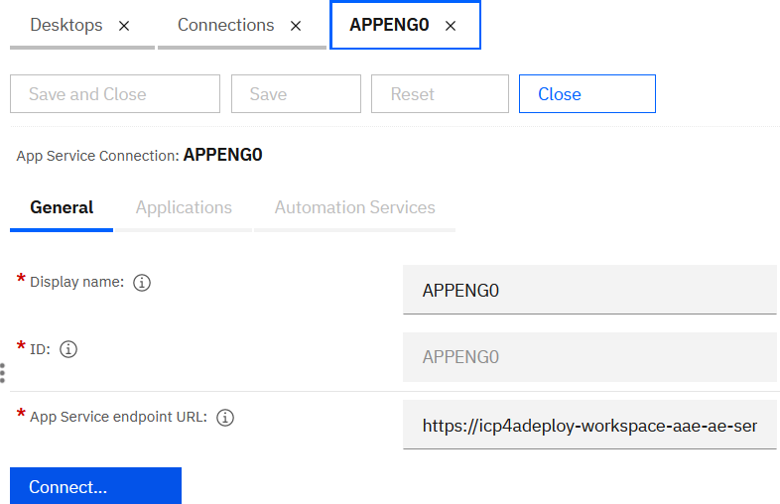

The Applications tab is enabled.

10. Click the Applications tab, click Import, click Choose Files, and locate the exported .zip file that you exported from Business Automation Studio in your authoring environment.

11. Click Open.

You can import only one file at a time.

12. Click Import.

If you have more than one application to import, repeat the steps to import additional application .zip files.

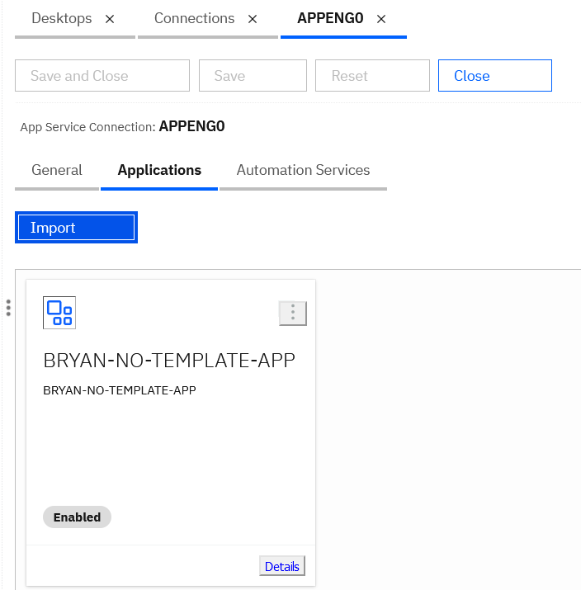

13. Click the Desktops tab. Click New Desktop > Platform and content to create the desktop where you will host your application.

You can also use an existing desktop to host the application, in which case, confirm the following settings for your existing desktop.

Add the following values:

* General tab
  + Name: Provide a name for the desktop.
  + ID: A shortened way to identify your desktop in a URL.
  + Description: Optionally add a description for the desktop.
  + Authentication: Choose the Connection from the list.
  + Under Desktop Configuration, specify the Viewer map from the list, and specify whether to set this desktop as the default desktop.
  + Under Additional settings, check the following:

Allow users to configure role-based security in entry templates, documents, and folders.

Allow users to configure only role-based security in entry templates, documents, and folders

Allow users to configure the security inheritance of folders.

* Connections tab

Confirm that your previously created connections to APPENG0 and your runtime object store for Document Processing are listed under Selected Connections. You can test the connection to the object store to make sure your credentials are correct.

Click the Repositories tab, find your object store in the list, and click Edit.

On the General tab, click Connect, and supply the login credentials to the object store to test the connection. Check or supply the values for the following fields:

* + Object store symbolic name
  + Object store display name
* Layout tab

For Displayed features, find and select the applications that you created.

Select in the Displayed Feature list:

* + Your imported application

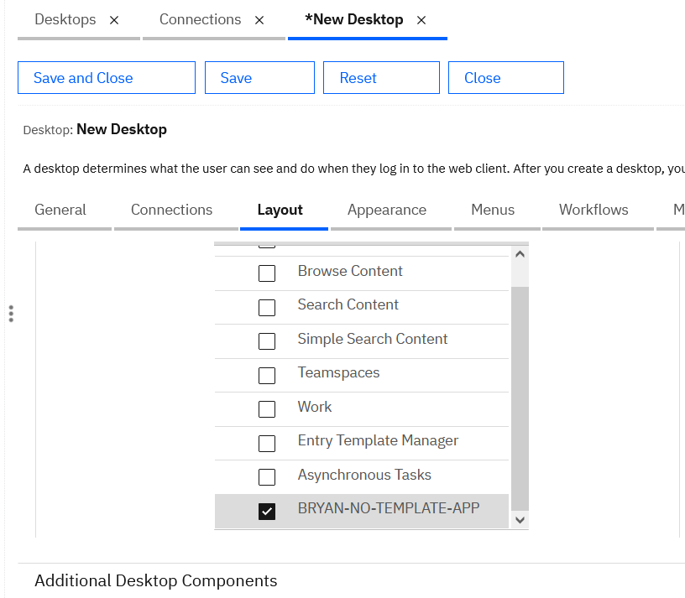

14. To access to your new desktop, use a URL with the following construction:

Navigator.*server_name.domain.com*/navigator/?desktop=NewID

Where NewID is the value for ID that you specified on the General tab during setup.

NOTE: For more details about importing your App to runtime, please see the latest IBM documentation for **IBM Cloud Pak for Business Automation - Moving your application to runtime**.